Communication Diagram – Create New Customer Profile Scenario (Normal)

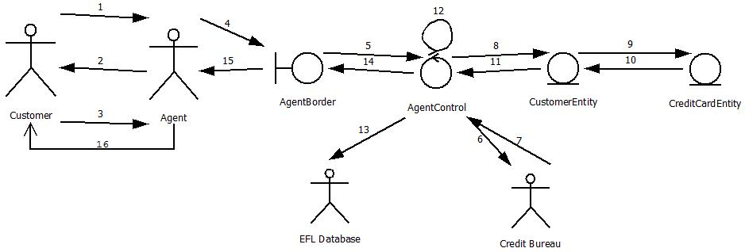

1. New Customer calls or enters the travel agency and would like to create an account
2. Agent explains fee structure and requests information from customer
3. Customer accepts services and provides information and credit card
4. Agent enters information into CreateAccount subscreen
5. Agent Verifies information is correct and hits submit to send information to AgentControl
6. AgentControl sends credit card info to be verified by Credit Bureau
7. Credit Information is cleared
8. AgentControl calls to create a new instance of Customerentity
9. CustomerEntity calls to create a new instance of CreditCardEntity
10. CreditCardEntity returns a new instance of itself to CustomerEntity
11. CustomerEntity returns a new instance of itself to AgentControl
12. AgentControl updates the new class with current info
13. AgentControl sends customer to EFLDatabase
14. AgentControl sends updated display to AgentBorder with customer instance
15. AgentBorder updates display to Agent
16. Agent Reports a successfully created account

Communication Diagram – Create New Customer Profile Scenario (Exception 3B)

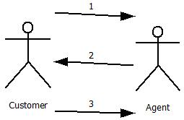

1. New Customer calls or enters the travel agency and would like to create an account
2. Agent explains fee structure and requests information from customer
3. Customer rejects services

Communication Diagram – Create New Customer Profile Scenario (Exception 5B)

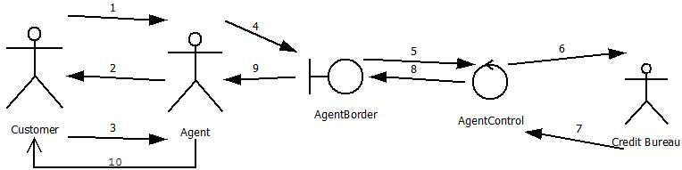

1. New Customer calls or enters the travel agency and would like to create an account
2. Agent explains fee structure and requests information from customer
3. Customer accepts services and provides information and credit card
4. Agent enters information into CreateAccount subscreen
5. Agent Verifies information is correct and hits submit to send information to AgentControl
6. AgentControl sends credit card info to be verified by Credit Bureau
7. Credit Information is invalid or unsatisfactory
8. AgentControl sends updated display to AgentBorder with error message
9. AgentBorder updates display to Agent
10. Agent Reports a successfully created account